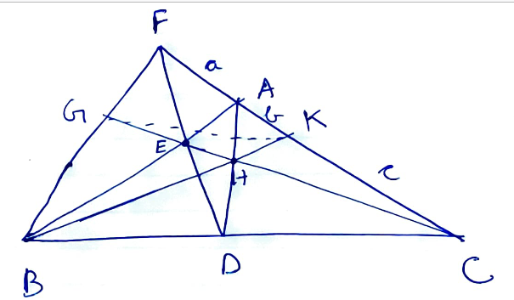
Given :
$$\frac{BD}{DC}=\frac{1}{2}$$
To Prove : GK $∥$ BC
Proof :
Let AF = a
AK = b
KC = c for ease.
In FBCA,
FD, BA, CG are concurrent at E.
$∴$ Bye Ceva's
$$\frac{BD}{DC}×\frac{CA}{AF}×\frac{FG}{GB}=1$$
$$⇒\frac{1}{2}×\frac{(b+c)}{a}×\frac{FG}{GB}=1$$
$⇒\frac{FG}{GB}×\frac{2a}{b+c}$ ---------------------------(1)
In $∆$ ABC,
AD,BK,CE meet at H
$$∴\frac{BD}{DC}×\frac{CK}{KA}×\frac{AE}{EB}=1$$
$$⇒\frac{1}{2}×\frac{c}{b}×\frac{AE}{EB}=1$$
$⇒$ $\frac{AE}{EB}=\frac{2b}{c}$
In $∆$ABC, FD transversal
by Menulaus,
$$\frac{CF}{FA}×\frac{AE}{EB}×\frac{BD}{DC}=1$$
$⇒$ $\frac{a+b+c}{a}×\frac{2b}{c}×\frac{1}{2}=1$
$⇒$ $b(a+b+c)$ = ac
$⇒$ $ab+b^{2}+bc=ac$
+ac +ac
$$⇒ ab+b^{2}+bc+ac=2ac$$
$⇒$ $b\left(a+b\right)+c\left(a+b\right)=2ac$
$⇒$ (b+c)(a+b)=2ac
$$⇒\frac{2a}{b+c}=\frac{a+b}{c}$$
$⇒\frac{2a}{b+c}=\frac{FK}{KC}$
Master. Peeyush Pande
$$⇒\frac{FG}{GB}=\frac{FK}{KC}$$
by inverse BPT, GK $∥$ BC
********************

